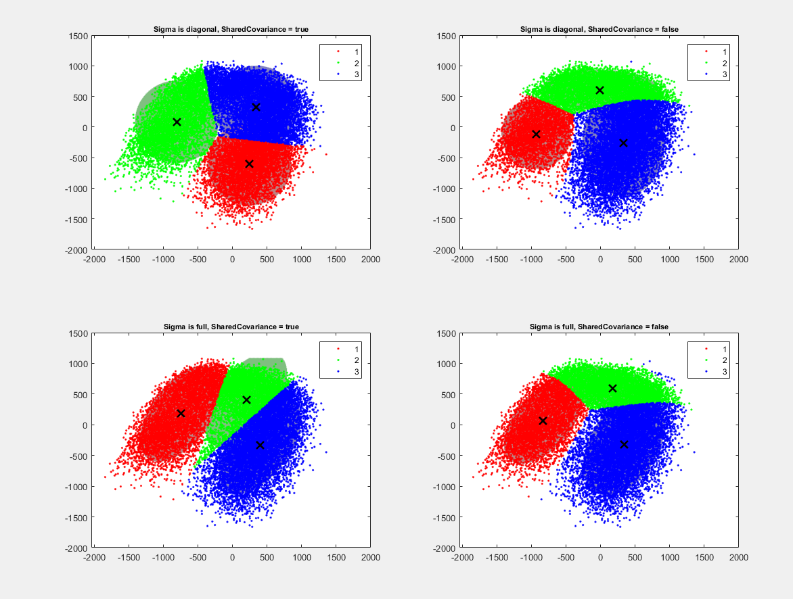

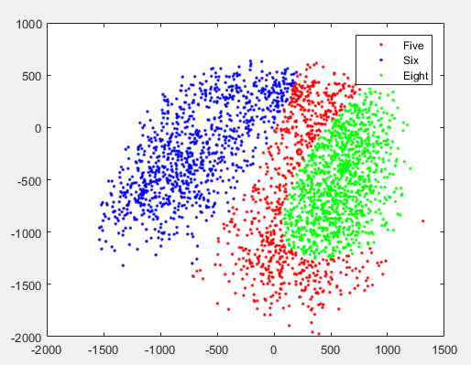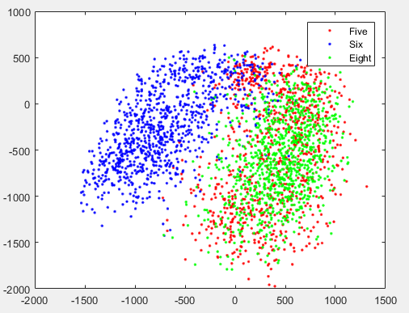

|  |  |  |  |  |  |
| --- | --- | --- | --- | --- | --- |
|  | **Diag, Shared** | **Diag, Diff** | **Full, Shared** | **Full, Diff** | **Dim Redux** |
| **Mean1 (x,y)** | 241.0429,  -606.4923 | -933.4577,  -112.7757 | -752.1196, 180.6561 | -832.7579, 62.5048 | -832.7579, 62.5048 |
| **Mean2 (x,y)** | -808.8862, 84.3273 | -11.4418, 604.4417 | 197.3291, 400.5303 | 172.9033, 592.9637 | 172.9033, 592.9637 |
| **Mean3 (x,y)** | 341.9994, 327.4778 | 331.3292,  -256.5128 | 397.4750,  -336.8129 | 339.0277,  -323.7212 | 339.0277,  -323.7212 |
| **Sigma1** | 1.1923, 1.4695 | 0.8187, 1.0600 | 1.1364, 0.8254,  0.8254, 1.9937 | 1.0591, 0.7170,  0.7170, 1.5774 | 1.0591, 0.7170,  0.7170, 1.5774 |
| **Sigma2** | 1.1923, 1.4695 | 2.3506, 0.3415 | 1.1364, 0.8254,  0.8254, 1.9937 | 1.6798,  -0.3315,  -0.3315, 0.3904 | 1.6798,  -0.3315,  -0.3315, 0.3904, |
| **Sigma3** | 1.1923, 1.4695 | 1.1577, 2.4833 | 1.1364, 0.8254,  0.8254, 1.9937 | 1.1354, 0.6559,  0.6559, 2.2059 | 1.1354, 0.6559,  0.6559, 2.2059 |

Sigma is calculated 1.0e+5 * x